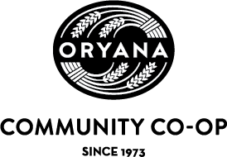
General Ownership Meeting Agenda Thursday, April 20,2023
Traverse City Central High School 5:30 p.m. – 8:00 p.m.
5:30 | Dinner, Dessert & Socializing
6:00 | Thank you to Oryana Staff & Introduction of Board President  By Steve Nance, General Manager
6:05 | Call to order of Oryana Business Meeting & Introduction of Current Board  By Colleen Valko, Board President
6:10 | Approval of the 2022 GOM Minutes  By Holly Jo Sparks, Board Secretary
6:15 | Treasurer’s Report  By Cy Agley, Board Treasurer
6:20 | Call for Board Candidates from floor, Introduction of Candidates Statements (2 minutes each) By Colleen Valko, Board President
6:35 | Break for final voting  By Colleen Valko, Board President
6:50 | Voting closes  By Colleen Valko, Board President  Board Update & State of the Co-op Address  By Colleen Valko, Board President & Steve Nance, General Manager
7:25 | Q & A for the Board and General Manager
7:40 | Announcement of the 2023 Board Election Results  Public Comments (2 minutes each, please)  By Colleen Valko, Board President
7:50 | Close of Meeting  By Colleen Valko, Board President
1

